Step by Step Instructions - Using Realm to Make 155th Church Anniversary Birthday Competition Donation
- Log into Realm at https://onrealm.org/zbcmarietta/SignIn
- Enter your email address and password
- Click on Sign In
- Click on Forgot your password? If you need help signing in.
- Click on Giving
- Click on +Give
- Enter the amount, find Anniv Birthday Competition by clicking on the down
arrow
- Enter your birth month in the Memo section
- Select the payment date
- Then click Continue
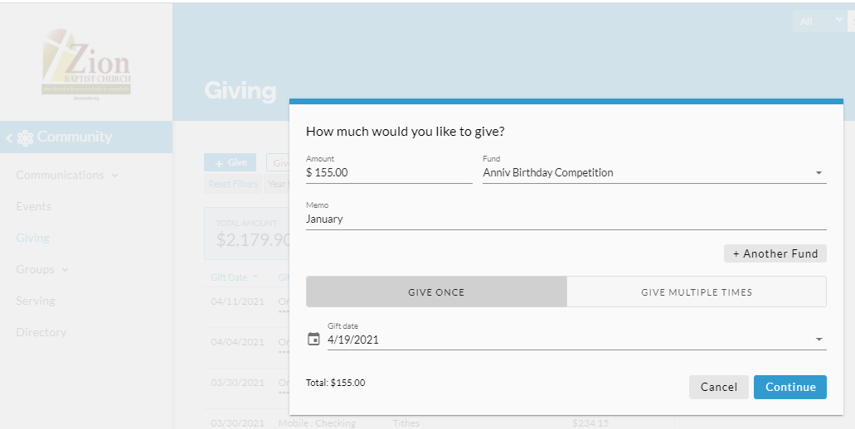

- Select your Payment Method – Preferred method is a checking account
- Then click Give $XXX.XX
- A brief screen will appear as your donation is being processed.
- The confirmation screen below will be shown when your donation/gift has been processed/scheduled if a future date was selected for the payment date.
- Click Finish

The summary screen displayed next will show the amount that was just donated or scheduled to be donated for the Birthday Competition for Zion’s 155th Church Anniversary
- Click Finish

- A confirmation email will be sent to the email that you have in your profile

